Acorn lesson plan

From Little Acorns. book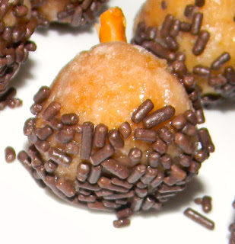Snack: donut hole, pretzel stick, sprinkles

Acorn sink/float
Acorn sort cap/no caps
Mr. Squirrel Game

To play, place an acorn under a chair and choose a player to be "the squirrel."

The squirrel sits in the chair and closes his/her eyes while another player snatches the acorn.

Then the group chants: "Mr. Squirrel, Mr. Squirrel, someone took your acorn from you. Who could it be?"
All players put their hands behind their back or make fists so it's not obvious who holds the acorn, and Mr. Squirrel tries to guess who has his acorn.
Obviously this is more challenging with a larger group, but my kids loved playing it with just four of us. Everyone had plenty of turns to be Mr. Squirrel!

Library books:
Acorns everywhere!
Author
Sherry, Kevin.
Acorn alone : a story for children
Author
McClure, Michael, 1953-

Radio WOOF presents forbidden folklore! [sound recording]
Author
Wellington, Bill.
  - From little acorns-- : a first look at the life cycle of a tree
Author
Godwin, Sam.
Call number
  - Title
The Busy little squirrel
Author
Tafuri, Nancy
Call number
PUPPET - TAFUR
  - Curious George. Zoo night and other animal stories [videorecording]
Author
Macy, William H., 1950-
Call number
J DVD CURI
Nuts to you!
Author
Ehlert, Lois

Gather oak leaves and wax them in the paraffin wax

Squirrel bags # 1-9 – put that many acorns in the bag
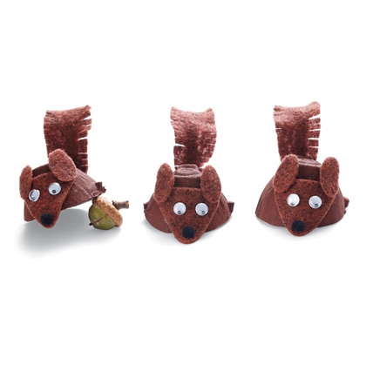

http://littlewondersdays.blogspot.com/2011/10/squirrel-drey-craft-and-fall-nature.html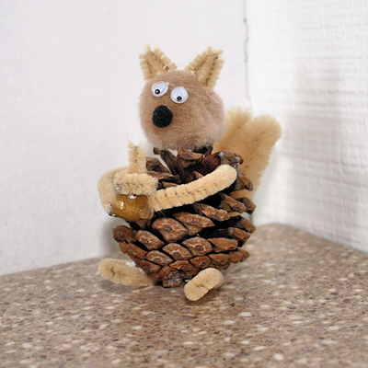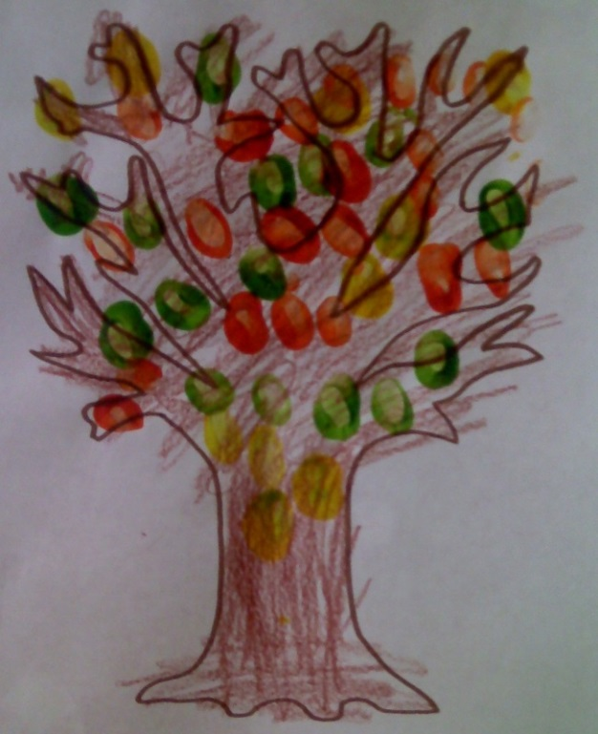
Leaf Creations
Materials: leaves, crayons, glue, white construction paper
Take your students on a leaf walk and have them select one leaf each to bring back to class with them. Glue the leaf on to the paper and add features, such as arms and legs, head, or tail. These look fantastic on the wall, you’ll be surprised how creative your students can be with this project. This is a great activity to accompany the new book by Lois Ehlert, Leaf Man.
Wax leaves with hand waxer
Playdough leaf fossils- roll dough and imprint leaves.
Leaf shape on card stock- whole punch & lace with yarn and plastic needle
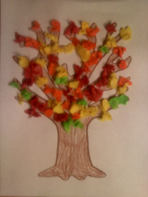 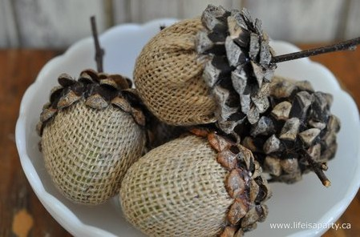 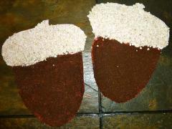oatmeal & ground coffee

I'm an acorn, small and round
Pretend to hold an acorn in your fingers.
Lying on the cold, cold ground.
Cross your arms on your chest and shiver .
People always step on me.
Touch your foot to the ground on "step."
That is why I'm cracked, you see.
Make a fist and tap your head on "cracked."
Chorus:
I'm a nut.
After singing this line, lightly rap your head twice,
as you click your tongue.
I'm a nut.
Rap your head again.
I'm a nut. I'm a nut. I'm a nut.
Rap your head again.
I'm so nutty, I don't know
Why the squirrels love me so.
I'm descended from an oak.
Nuts to you, and that's no joke.
Chorus

