Fire Safety Lesson
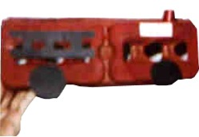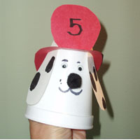 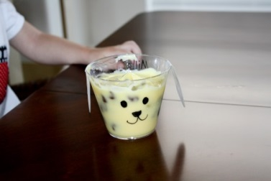 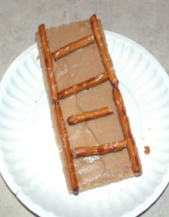
Fire fighter: Karen Will from Rockingham County Fire Dept. will come and talk at 9:15 and bring a fire truck
Lt. Karen L. Will
Public Education Officer
Rockingham County Fire & Rescue
20 East Gay Street
Harrisonburg, VA. 22802
(540)-564-3175 Office
kwill@rockinghamcountyva.gov

Play “Fire Fighter Says”, like Simon Says.
Fire Truck prints with wheels of the trucks dipped in paint and rolled across blank papers.
Fire truck race: Pretend to be a fire truck and race from point A to B.
Smoke crawl race: crawl from A to B.
I’m a Big Red Fire Truck
(I’m a Little Teapot)
I’m a big red fire truck long and stout,
When I am needed, I roar and shout.
People love to see me rush about,
Just turn me on and head me out.
I’m a big red fire truck stout and long,
Here’s is my ladder, tall and strong.
When I get a call, you’ll hear my song,
Just climb aboard and turn me on.
Hot And Cold…
Purchase tiny red and blue dot stickers from Office Depot and bring some items and pictures into the daycare for the kids to sort into piles. Under the red dot could be a stove, lighter, fire etc.Under the blue dot could be items like shoes, clothing, furniture etc.
9-1-1 song (Sung to the tune of 'This Old Man')
9-1-1, 9-1-1,
Press the buttons, 9-1-1
If you're hurt and scared and you don't know what to do
9-1-1 sends help to you.
Five little firefighters sleeping in a row.
Ring goes the bell, down the pole they go.
They jump on the engine and put out the fire.
Now they're back home, but they sure are tired.
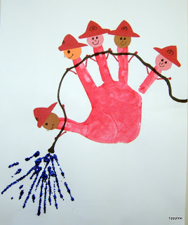Oh where, Oh where has the fire dog gone? Song/ Games

Books:
Home: Fire, Fire! By Gail Gibbons
Tonka: Working hard with the busy fire truck
Library: Stop, Drop & Roll by Margery Cuyler
Firefighter by Dana Rau
DK Fire Truck board book
Video: Caillou’s Family Fun-

Five little firefighters sleeping in a row.
Ring goes the bell, down the pole they go.
They jump on the engine and put out the fire.
Now they're back home, but they sure are tired.
Five little firefighters sleeping in a row.
Ring goes the bell, down the pole they go.
They jump on the engine and put out the fire.
Now they're back home, but they sure are tired.

Five little firefighters sleeping in a row.
Ring goes the bell, down the pole they go.
They jump on the engine and put out the fire.
Now they're back home, but they sure are tired.

Five little firefighters sleeping in a row.
Ring goes the bell, down the pole they go.
They jump on the engine and put out the fire.
Now they're back home, but they sure are tired.
Five little firefighters sleeping in a row.
Ring goes the bell, down the pole they go.
They jump on the engine and put out the fire.
Now they're back home, but they sure are tired.

Five little firefighters sleeping in a row.
Ring goes the bell, down the pole they go.
They jump on the engine and put out the fire.
Now they're back home, but they sure are tired.
Five little firefighters sleeping in a row.
Ring goes the bell, down the pole they go.
They jump on the engine and put out the fire.
Now they're back home, but they sure are tired.

