Harvest/Corn/Popcorn

Corn sensory tub
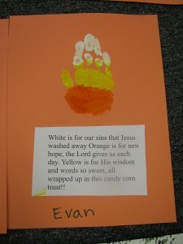
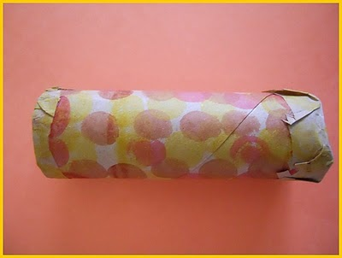Dot a Dot markers and fill with popcorn.
Make popcorn & watch it pop- talk about the heat expanding the water inside the seed to make it pop open.

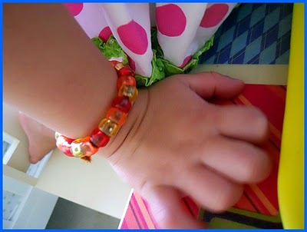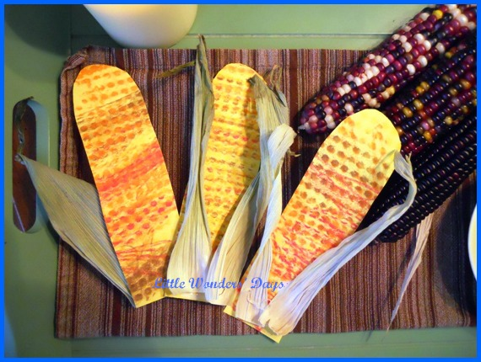 corn cob painting
Playdough corn cob imprints
I'm A Little Cornstalk (Tune: I'm A Little Teapot)
I'm a little cornstalk tall and stout,
see me grow and watch me sprout.
When I'm brown, you can shuck me down.
Boil me up and I'm the best in town.
Popcorn
Pop! Pop! Pop! Popcorn in the pot.
(Hands jump up and down quickly.)
Pop! Pop! Pop! Watch out! It's hot!
(Pill hand back quickly.)
Pop! Pop! Pop! Fill up your dishes.
(Scoop with one hands into cupped other hand.)
Pop! Pop! Pop! Popcorn is delicious!
(Rub tummy.)

Books:
*Corn by Gail Gibbons
The Popcorn Book by Tomie de Paola
The Berenstain Bears Reap the Harvest
Corn is Maize by Aliki
Snack: Popcorn- make and talk about while making, corn pops cereal

White is for our sins that Jesus washed away.
Orange is for new hope, the Lord gives us each day.
Yellow is for His wisdom and words so sweet.
All wrapped up in this candy corn treat!

White is for our sins that Jesus washed away.
Orange is for new hope, the Lord gives us each day.
Yellow is for His wisdom and words so sweet.
All wrapped up in this candy corn treat!

White is for our sins that Jesus washed away.
Orange is for new hope, the Lord gives us each day.
Yellow is for His wisdom and words so sweet.
All wrapped up in this candy corn treat!

