Monkeys

5 Little Monkey’s book and puppets
Curious George Books 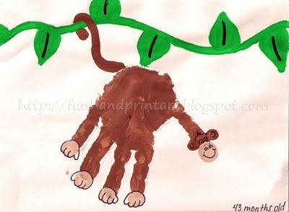
Snack: Monkey bread, Bananas
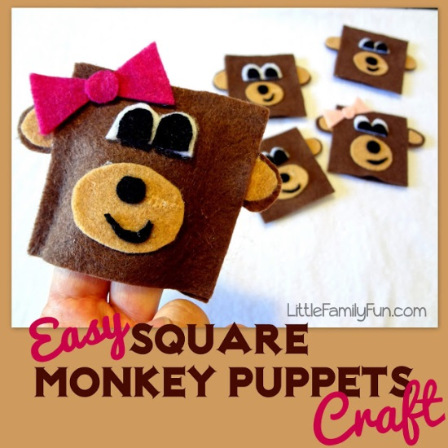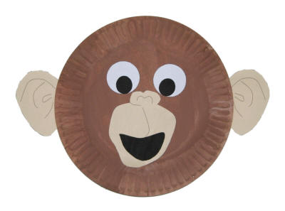
  - Curious George. Zoo night and other animal stories [videorecording]
Author
Macy, William H., 1950-

Adapt a traditional "Simon Says" game to play "Monkey Say, Monkey Do." Call out silly movements like hopping, scratching, or other "monkey" actions; when you preface it with "Monkey says," children follow the movement you model, but they do not copy the actions when you leave off the phrase. DLTK print for plate face

Copy and cut bananas to “feed” a stuffed monkey. Use dice to roll how many bananas the monkey gets.

Adapt a traditional "Simon Says" game to play "Monkey Say, Monkey Do." Call out silly movements like hopping, scratching, or other "monkey" actions; when you preface it with "Monkey says," children follow the movement you model, but they do not copy the actions when you leave off the phrase. DLTK print for plate face



